Integrate Mimecast to sentinel SIEM.,

**Configuration:**

1. **Configuration steps for the Mimecast API**

Go to ***Azure portal ---> App registrations ---> [your_app] ---> Certificates & secrets ---> New client secret*** and create a new secret (save the Value somewhere safe right away because you will not be able to preview it later)

1. **Deploy Mimecast API Connector**

**IMPORTANT:** Before deploying the Mimecast API connector, have the Workspace ID and Workspace Primary Key (can be copied from the following), as well as the Mimecast API authorization key(s) or Token, readily available.

1. Now from Option 1, click on Deploy To Azure,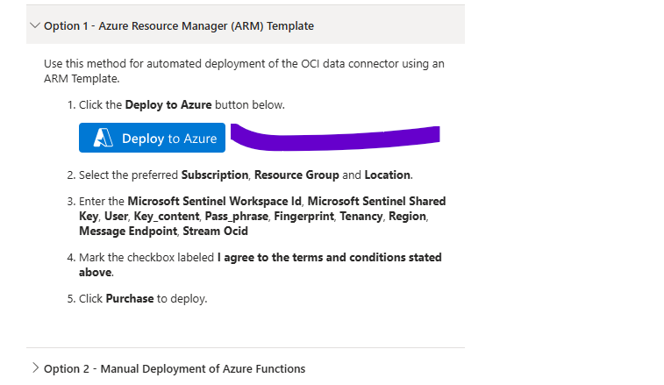
2. Now here fill all the details below.

Here, under User tab we need to fill user detail who is generating private key…Instead depending on that person, we can tell them to create a Service account and provide all necessary permission to OCI portal and use that service account details under User field.

The mandatory is, Fingerprint, Private Key from OCI portal and all other details must and should be given by OCI team.

Note: Whatever region you are selecting, get above values from same region, then only it will work like if you are taking private key from one region and fingerprint from one region that doesn’t work.,

App Insights Workspace Resource ID: For this one, go to to particular log analytics workspace, under overview, go to Json View and their will get it as below.,

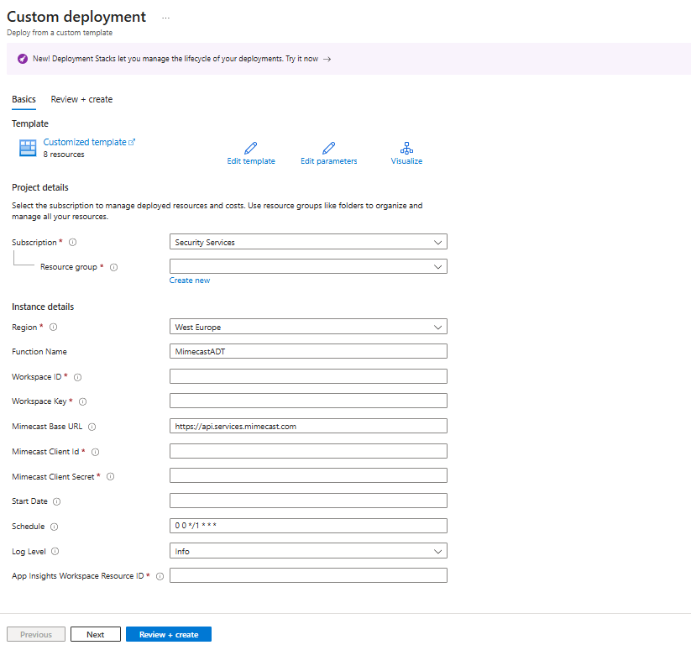

1. Once done click review and create. After this a Function app will be created.
2. To validate the log ingetion, goto Senitnel >> Logs, and run below query,

Audit_CL

| where TimeGenerated >ago(1d)

Ref: <https://mimecastsupport.zendesk.com/hc/en-us/articles/34000590303379-API-Integrations-Microsoft-Sentinel-Integration#h_01J9KG61WQB404VZXT8DZBTCGX>